Session-2

1).Open MySQL Workbench or CLI and write a CREATE TABLE statement to create a table called 'restaurants' with columns: id (INT, primary key, auto-increment), name (VARCHAR(100)), location (VARCHAR(100)), and rating (DECIMAL(2,1)).
Ans)
CREATE TABLE restaurants (
id INT AUTO_INCREMENT PRIMARY KEY,
name VARCHAR(100),
location VARCHAR(100),
rating DECIMAL(2,1)
);

Output:-
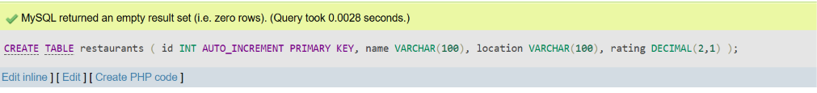

2).Use the ALTER TABLE command in MySQL to add a new column 'average_cost' (INT) to your 'restaurants' table.<br><br><em><strong>Hint:</strong> Remember to specify the data type when adding a new column.</em>
Ans)
ALTER TABLE restaurants
ADD average_cost INT;

Output:-
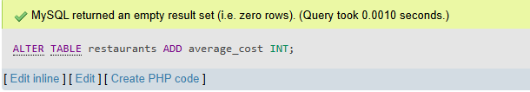

3).Write a SQL statement to DROP the 'restaurants' table you created earlier. Double-check your command before running it to avoid accidental data loss.
Ans)
DROP TABLE restaurants;

Output:-
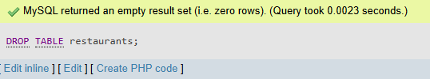

4).Create a new table called 'playlists' for a music app like Spotify, with columns: playlist_id (INT, primary key, auto-increment), title (VARCHAR(50)), created_by (VARCHAR(50)), and created_at (DATE).
Ans)
CREATE TABLE playlists (
playlist_id INT AUTO_INCREMENT PRIMARY KEY,
title VARCHAR(50),
created_by VARCHAR(50),
created_at DATE
);
Output;-
